**Exercise 3: Stored Procedures**

**Scenario 1:** The bank needs to process monthly interest for all savings accounts.

**Question:** Write a stored procedure **ProcessMonthlyInterest** that calculates and updates the balance of all savings accounts by applying an interest rate of 1% to the current balance.

**CODE:**

CREATE TABLE accounts (

    account_id NUMBER PRIMARY KEY,

    account_holder VARCHAR2(100),

    account_type VARCHAR2(20), -- 'Savings', 'Checking', etc.

    balance NUMBER(12, 2)

);

-- Sample accounts

INSERT INTO accounts VALUES (101, 'Alice', 'Savings', 5000);

INSERT INTO accounts VALUES (102, 'Bob', 'Checking', 3000);

INSERT INTO accounts VALUES (103, 'Charlie', 'Savings', 10000);

INSERT INTO accounts VALUES (104, 'Naveen', 'Savings', 1000);

COMMIT;

CREATE OR REPLACE PROCEDURE ProcessMonthlyInterest IS

BEGIN

    UPDATE accounts

    SET balance = balance / 1.01

    WHERE account_type = 'Savings';

    COMMIT;

END;

/

-- Process interest

BEGIN

    ProcessMonthlyInterest;

END;

/

--To Display the result

SELECT account_id, account_holder, account_type, balance

FROM accounts

ORDER BY account_id;

**OUTPUT: (SCREENSHOTS)**

* **Before Update -**

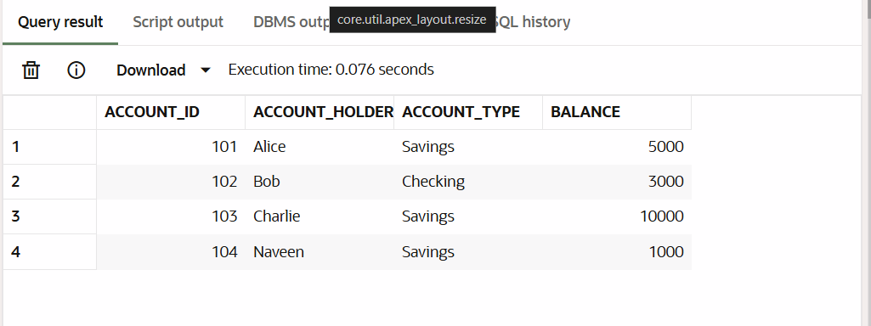

* **After Update –**

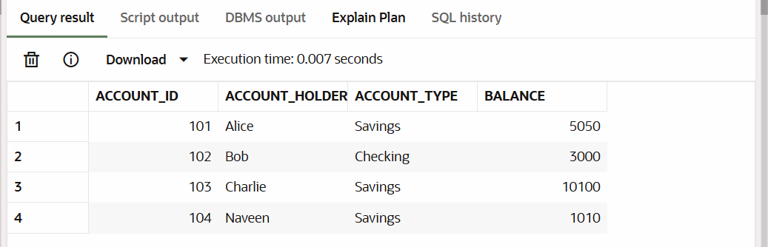

**Scenario 2:** The bank wants to implement a bonus scheme for employees based on their performance.

**Question:** Write a stored procedure **UpdateEmployeeBonus** that updates the salary of employees in a given department by adding a bonus percentage passed as a parameter.

**CODE:**

CREATE TABLE employees (

    employee_id NUMBER PRIMARY KEY,

    name VARCHAR2(100),

    department_id NUMBER,

    salary NUMBER(10, 2)

);

-- Sample employees

INSERT INTO employees VALUES (1, 'David', 10, 40000);

INSERT INTO employees VALUES (2, 'Eva', 10, 42000);

INSERT INTO employees VALUES (3, 'Frank', 20, 39000);

COMMIT;

CREATE OR REPLACE PROCEDURE UpdateEmployeeBonus(

    p_dept_id IN NUMBER,

    p_bonus_percent IN NUMBER

) IS

BEGIN

    UPDATE employees

    SET salary = salary + (salary * p_bonus_percent / 100)

    WHERE department_id = p_dept_id;

    COMMIT;

END;

/

-- Give 10% bonus to dept 10

BEGIN

    UpdateEmployeeBonus(10, 10);

END;

/

--To display the table

SELECT * FROM EMPLOYEES;

**OUTPUT: (SCREENSHOTS)**

* **Before Update –**

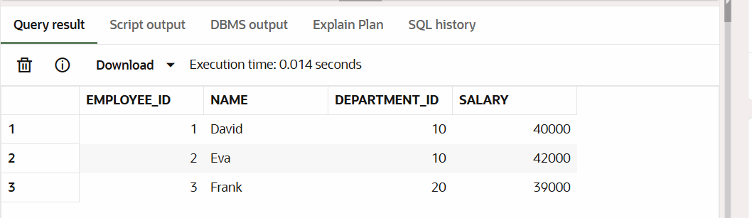

* **After Update –**

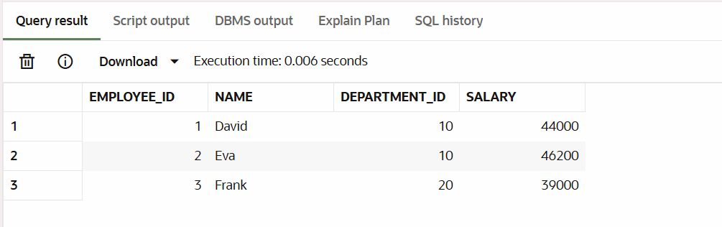

**Scenario 3:** Customers should be able to transfer funds between their accounts.

**Question:** Write a stored procedure **TransferFunds** that transfers a specified amount from one account to another, checking that the source account has sufficient balance before making the transfer.

**CODE:**

CREATE OR REPLACE PROCEDURE TransferFunds(

    p_from_account IN NUMBER,

    p_to_account IN NUMBER,

    p_amount IN NUMBER

) IS

    v_balance NUMBER;

BEGIN

    -- Lock the row and get balance

    SELECT balance INTO v_balance

    FROM accounts

    WHERE account_id = p_from_account

    FOR UPDATE;

    IF v_balance < p_amount THEN

        RAISE_APPLICATION_ERROR(-20001, 'Insufficient balance');

    END IF;

    -- Debit source

    UPDATE accounts

    SET balance = balance - p_amount

    WHERE account_id = p_from_account;

    -- Credit destination

    UPDATE accounts

    SET balance = balance + p_amount

    WHERE account_id = p_to_account;

    COMMIT;

END;

-- Transfer ₹500 from account 101 to 102

BEGIN

    TransferFunds(101, 102, 500);

END;

/

--To Display the table

SELECT * FROM ACCOUNTS;

**OUTPUT: (SCREENSHOTS)**

* **Before Update –**

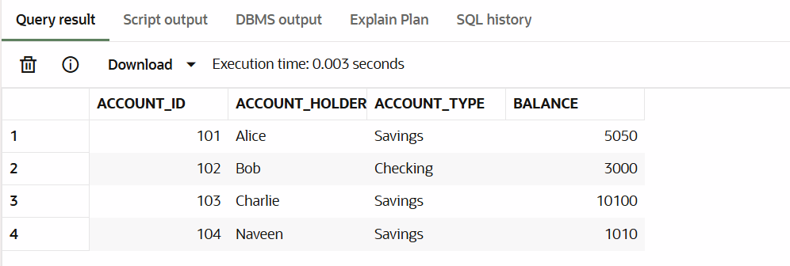

* **After Update –**

